Contents

SharePoint 2013: Using the search REST service from an app for SharePoint 2

Description of the SearchApp sample 2

Prerequisites 2

Key components of the sample 2

Configure the sample 3

Build the sample 3

Run and test the sample 3

Troubleshooting 3

Change log 3

Related content 3

# SharePoint 2013: Using the search REST service from an app for SharePoint

This documentation is preliminary and is subject to change.

Summary:  Learn how to submit a search query to Search in SharePoint 2013 Preview from within an app for SharePoint.

## Description of the SearchApp sample

This sample demonstrates how to return search results in an app for SharePoint. The SearchApp sample accepts a query using the keyword query language (KQL) syntax as an input. It subsequently makes a call to the search engine using the search Representational State Transfer (REST) service. The results are then displayed in a table, which is built dynamically using JQuery and JavaScript. The following screen shot shows search results displayed on the home page of the sample.

Figure 1. Home.aspx page in the app, displaying the search results

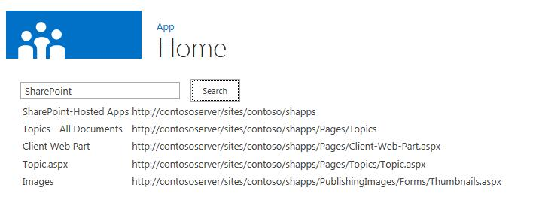

## Prerequisites

This sample requires the following:

* Visual Studio 2012
* SharePoint development tools in Visual Studio 2012
* A SharePoint 2013 Preview development environment

## Key components of the sample

The sample app contains the following:

* SearchApp project
* AppManifest.xml file, located in the SearchApp directory
* Home.aspx file, located in the SearchApp\Pages directory, which contains the HTML and ASP.NET controls for the sample’s user interface
* App.js file, located in the SearchApp\Scripts directory, which contains the JavaScript code that populates the controls in the Home.aspx file

## Configure the sample

To configure SearchApp sample, update the SiteUrl property of the solution with the URL of the home page of your SharePoint 2013 Preview site.

## Build the sample

Press the F5 key to build and deploy the app.

## Run and test the sample

Enter a KQL query in the Search box and click Search to view the results.

## Troubleshooting

The following table lists common configuration and environment errors that prevent the sample from running or deploying properly and how you can solve them.

| Problem | Solution |
| --- | --- |
| Visual Studio does not open the browser after you press the F5 key. | Set the app for SharePoint project as the startup project. |
| The SearchApp app for SharePoint sample fails to install. | Ensure that the value you specified for the SiteUrl property is correct. |

## Change log

| Version | Date |
| --- | --- |
| First version | July 16, 2012 |

## Related content

* [SharePoint Search REST API Overview](http://msdn.microsoft.com/library/8a4f7863-e4c1-4099-9189-a1894db36930.aspx)
* [SharePoint 2013 development overview](http://msdn.microsoft.com/library/f86e2695-4d7a-4fc5-bc23-689de96c4b06.aspx)
* [Getting started developing SharePoint apps](http://msdn.microsoft.com/library/d07e0a13-1e74-4128-857a-513dedbfef33.aspx)
* [Architecture of the app for SharePoint model](http://msdn.microsoft.com/library/ae96572b-8f06-4fd3-854f-fc312f7f2d88.aspx)
* [Apps for SharePoint vs. classic SharePoint solutions](http://msdn.microsoft.com/library/0e9efadb-aaf2-4c0d-afd5-d6cf25c4e7a8.aspx)
* [Detailed introduction to the SharePoint app model](http://msdn.microsoft.com/library/ae96572b-8f06-4fd3-854f-fc312f7f2d88.aspx)